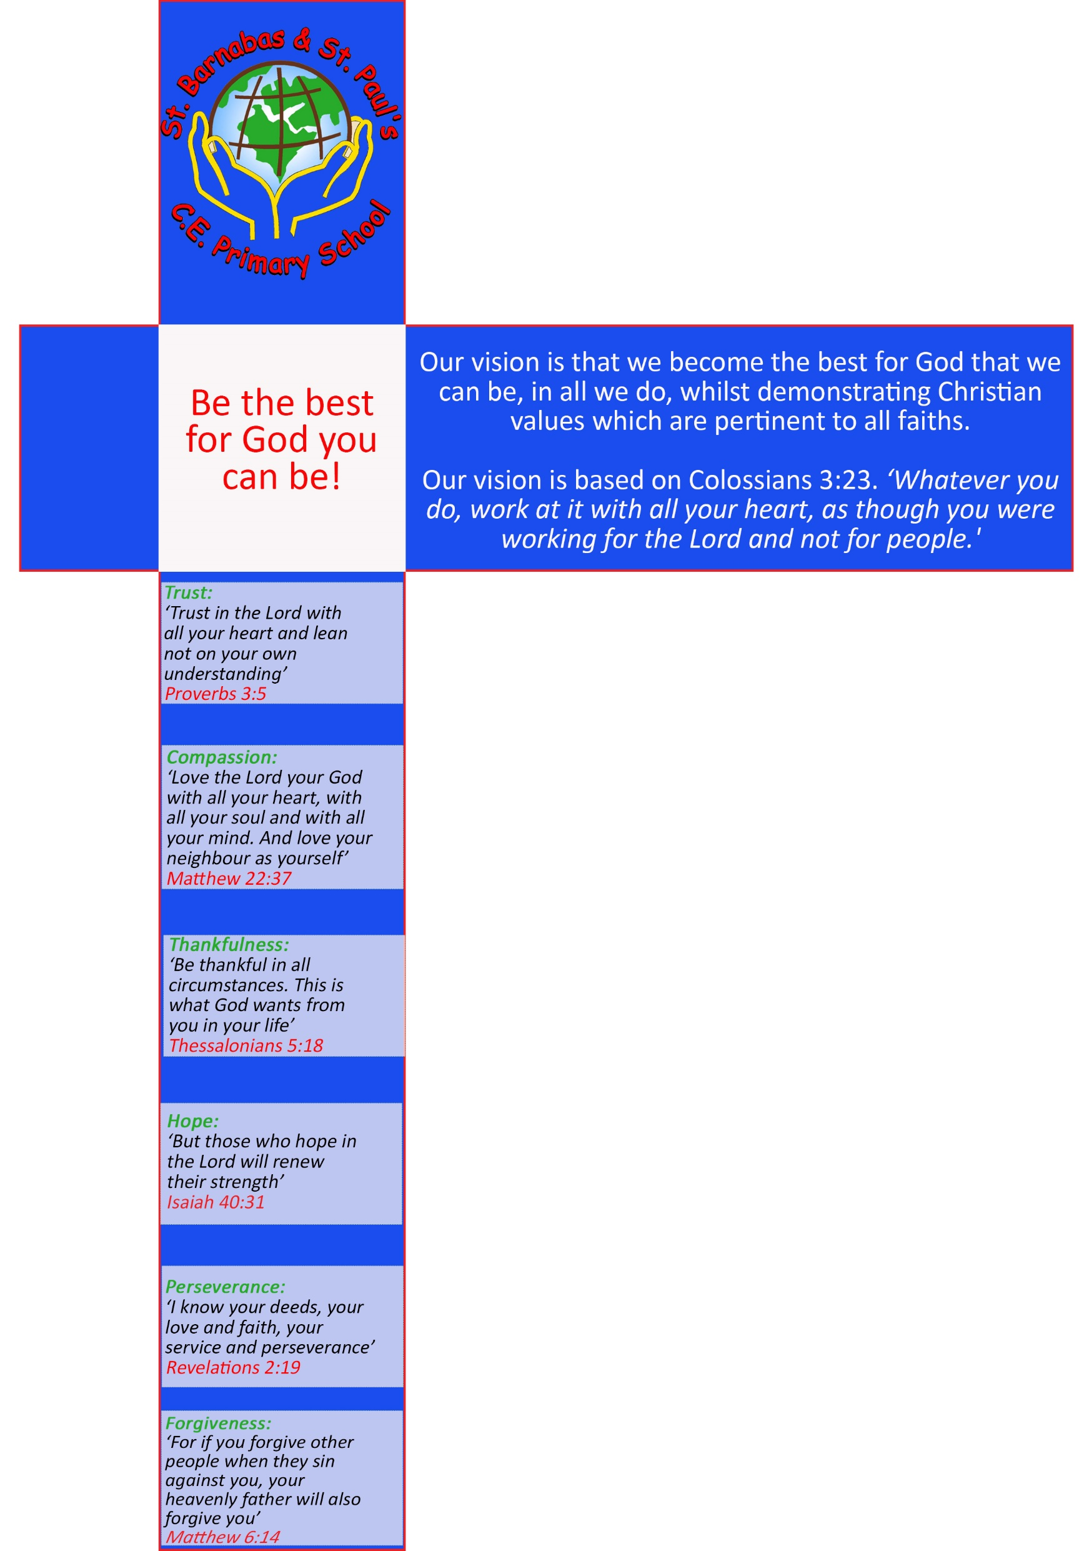
Physical
Education Policy

St Barnabas and St Paul’s Policy and Guidance for the Physical Curriculum

Section 1:
1. Statement of intent

At St Barnabas and St Paul’s Church of England Primary School, our vision is that we become the best for God that we can be, in all we do, whilst demonstrating Christian values which are pertinent to all faiths.
Our vision is based on Colossians 3:23, ‘Whatever you do, work at it with all your heart, as though you were working for the Lord and not for people.'

At St Barnabas and St Paul’s Primary School, we intend to provide children with an exciting and high-quality Physical Education curriculum, in order to instill a love of sport and an understanding of the importance of health and physical exercise in day to day life. Through our carefully sequenced curriculum, we aim to encourage and motivate children to have a love of exercise that will remain with them for the rest of their lives.
St Barnabas and St Paul’s Primary School offers a broad and balanced PE curriculum, that sits at the heart of our school curriculum and is based on the needs of the children within our school. We aim to provide a curriculum that is inspiring, motivational and inclusive for all our pupils. We believe it is of the upmost importance for every child to achieve their own personal best. Pupils are encouraged to improve their own and team performances in a range of sports across the subject. Strive to be the best you can be
We are passionate about creating and building a safe, secure and valued environment for our children to grow and flourish within. It is important pupils realise that PE involves mental strength and togetherness as well as other physical attributes.

The curriculum is progressive and covers a range of different sports, games and activities. It builds on prior learning and allows the children to practice previously learnt skills within new units. Our aim is to build competence for all our learners. This in turn develops motivation, team-work, self-esteem and confidence of our children.

By using high-quality schemes of work for planning, we believe our children will become increasingly confident in calling upon and successfully applying prior learning in a wide range of contexts.

Ofsted Review – PE
In September 2023, Ofsted published a literature review with the aim of identifying the factors which contribute to creating a high-quality PE curriculum. This guidance is very thorough and in-depth, investigating all possible areas of a PE curriculum, in primary and secondary school.

For the full document - https://www.gov.uk/government/publications/research-review-series-pe/research-review- series-pe

Declarative knowledge
This is factual knowledge concerning movement, rules, tactics, strategies, health and participation. This knowledge is not a list of disconnected facts; it is explicitly linked to the content being taught. Declarative knowledge can be communicated through verbal or written means. Pupils could, for example, demonstrate their declarative knowledge through question and answer sections of a lesson, or spoken or written observations of a practical demonstration.

Procedural knowledge
This can be viewed as knowing how to apply declarative facts and might include applying the tactics to a practice situation or modified game. This knowledge is best put into practice through physical demonstration or participation.
Learning starts in Reception, with a curriculum based around developing both fine and gross motor skills. During the Early Years, children’s physical development is of great importance. Fundamental Movement Skills are focused upon and taught through Continuous Provision and adult directed tasks. It is important for pupils to be encouraged to access these activities daily. Developing children’s motor skills is an integral part of their physical progression during the early years of their learning journey and builds the foundations for future skill building.
PE is taught through the Early Years Foundation Stage and as a foundation subject within the National Curriculum. The aims of PE teaching in the Early Years Foundation Stage is driven by children's interests and curiosity as part of the Physical Development aspect. Please see Appendix One 1. EYFS Component Knowledge

Opportunities will be planned to enable children to:

- Be active and interactive
- Develop their coordination, control with large and small movements.
- Understand the importance of physical activity
- Move confidently in a range of ways, safely negotiating space
- Make healthy choices in relation to food

In addition to the continuous opportunities to develop essential skills on a day to day basis, children also have designated Physical Education lessons. Units include:
- FMS
- Ball Skills
- Dance Team
- Gymnastics:
- Tots2Tyres
- Games
Building on this further in KS1, throughout the year, all pupils in Key Stage 1 fundamental movement skills, as outlined in the National Curriculum are heavily focused upon through the teaching of gymnastics, dance and lessons based around the skills themselves. Children also access skill-based lessons focusing on: target games; ball skills; team-building; striking and fielding; net and wall games; invasion games and athletics. Specialist coaches, funded by the school sports premium deliver some of these aspects.
Feeding into KS2, we carefully build on the children’s previous learning through a progressive development curriculum Following on from this, our intent in Upper KS2 allows children to further embed these skills and understanding. The National Curriculum requirements are delivered through the teaching of indoor and outdoor athletics, tag rugby, cricket, tennis, orienteering and other invasion games, such as tag-rugby and hockey. There is an increased focus on competition, tactical thinking and evaluating others’ performances and skills. Specialist coaches deliver some of these sessions. All Key Stage 2 pupils access swimming lessons for at least half a term each academic year.

  - Aims
- We aim to deliver a Physical Education curriculum that promotes physical competence, self-esteem, confidence, competition, team-work and respect.
- We aim for children to take initiative and focus on improving aspects of their own performance.
- We also aim to provide children with opportunities to extend their physical skills through extra-curricular activities.
- We aim to instil a sports-man like ethical approach to competition and help forge links between the school and wider community.
- We aim to help develop positive attitudes of participation in physical activity, enabling children to make informed decisions about the importance of maintaining an active lifestyle.

Section 2:
Roles and responsibilities

The subject leader is responsible for:

- Preparing policy documents, curriculum plans and schemes of work for the subject, liaising at all times with SLT.
- Reviewing changes to the national curriculum and advising on their implementation.
- Monitoring the teaching and learning of Physical Education, providing support and training for staff where necessary.
- Liaising with colleagues, including the SENCO, to differentiate teaching programmes in accordance with the needs of individual pupils.
- Ensuring the continuity and progression from year group to year group.
- Helping to develop colleagues’ expertise in the subject.
- Organising the deployment of resources and carrying out an annual audit of all Physical Education related resources.
- Communicating developments in the subject to all teaching staff.
- Organising, providing and monitoring CPD opportunities in the subject.
- Advising on the contribution of Physical Education to other curriculum areas, including cross-curricular and extra-curricular activities.
- Collating assessment data and setting new priorities for the development of Physical Education in subsequent years.
- Keeping staff informed of visits and courses.
- Facilitating the assessment of children’s work.
- Keeping up-to-date with current affairs and best practice regarding Physical Education.
- Celebrating and promoting the Physical Education curriculum and the work of pupils throughout the school.

The classroom teacher is responsible for:

- Acting in accordance with this policy.
- Ensuring progression of pupils’ Physical Educational skills in lessons, with due regard to the national curriculum.
- Developing, adapting and delivering lesson plans in line with the school’s Physical Education Policy and the objectives of the Physical Education curriculum and teaching lessons effectively, ensuring a range of teaching methods are used to cover the content of the national curriculum.
- Liaising with the subject leader about key topics, resources and support for individual pupils.
- Monitoring the progress of pupils in their class and intervening when concepts are not understood by pupils
- Undertaking any training that is necessary in order to effectively teach the subject.
- Assessing and recording pupils’ progress and keeping the Physical Education subject leader apprised of this.
- Providing feedback to parents and carers on pupils’ progress at parents’ evenings and other meetings.
- Keeping up to date on current affairs and best practice on their Physical Education curriculum, and applying this to their schemes of work.

The special educational needs coordinator (SENDCO) is responsible for:
- Advising staff how best to support pupils’ needs.
- Advising staff on the potential inclusion of Physical Education objectives in pupils’ individual education plans.
- Advising staff on the use of 1:1s in order to meet pupils’ needs.

3. Early years provision

Activities and experiences for pupils will be based on the seven areas of learning and development, as outlined in the DfE’s ‘Statutory framework for the Early Years Foundation Stage’.

Physical activity is vital in children’s all-round development, enabling them to pursue happy, healthy and active lives. Gross and fine motor experiences develop incrementally throughout early childhood, starting with sensory explorations and the development of a child’s strength, co-ordination and positional awareness. By creating games and providing opportunities for play both indoors and outdoors, adults can support children to develop their core strength, stability, balance, spatial awareness, co-ordination and agility.

Gross motor skills provide the foundation for developing healthy bodies and social and emotional well-being. Fine motor control and precision helps with hand-eye co-ordination, which is later linked to early literacy.
Repeated and varied opportunities to explore and play with small world activities, puzzles, arts and crafts and the practice of using small tools, with feedback and support from adults, allow children to develop proficiency, control and confidence.
Children have access to continuous indoor and outdoor provision throughout the year and undertake specific PE sessions for the duration of the year, including with specialist coaches. The EYFS curriculum prepares the children for the transition to KS1. Appendix 1b (How the EYFS Curriculum prepares children for Year 1) highlights how this smooth transition is mapped out.

4. The National Curriculum
The National Curriculum for Physical Educations aims to ensure that all pupils:
- develop competence to excel in a broad range of physical activities
- are physically active for sustained periods of time.
- engage in competitive sports and activities
- lead healthy, active lives.
The National Curriculum for Key Stage 1 and 2 is followed and appendix 1 provides a full breakdown of the content to be taught within each unit.

4.1 Cross-curricular links
Wherever possible, the physical education curriculum will provide opportunities to establish links with other curriculum areas. These include links between PE and English where pupils can write sequences; follow/give instructions; oral/peer assessments, speaking and listening and movement within drama. Pupils can use the following Mathematics skills to develop their physical education skills and techniques: measure, shape and space, sequences, number, angles, position and movement, rotation and time. ICT will be used to aid children to use capturing and recording equipment for evaluation/ development of skills. Videos of professional/skilled athletes are also used to help develop good technique. PSHE and PE links include following rules, living healthily, co-operating with others and understanding fairness and equality. As a result, pupils consider such ideas as inclusion, and fairness. Therefore, contributing to the British Values agenda.

5. Planning

All relevant staff members are briefed on the school’s planning procedures as part of their staff training and induction.

5.1 Long Term Plans and Medium Term Plans
At St Barnabas and St Paul’s we follow the ‘Get Set 4 PE’ scheme of work.

These long-term and medium-term plans map out the skills and themes covered each term for each key stage. The LTPs give the main overview of the coverage for each year group while the MTPs break this overview down into smaller steps and include key vocabulary that needs to be taught alongside it. These plans define what we will teach and ensure an appropriate balance and distribution of work across each term.
Appendix 2 shows our Long-Term Plan that ensures the curriculum programme is taught effectively and provides a powerful curriculum programme. External providers, including Sporting NRG, Blackburn with Darwen Borough Council (for swimming) and Blackburn Rovers Community Trust, help deliver several units of within the overview.

The LTPs and MTPs are used as a guidance tool in order to pace out coverage of the curriculum throughout the year. Teachers are encouraged to use professional discretion when deciding on how long is needed on a particular curriculum area whilst ensuring all objectives are covered by the end of the academic year.

5.2 Short term planning

Teachers will need to think carefully about their daily lesson plans, and use a 5-minute plan to adapt their teaching according to the teaching sequence. Teachers must ensure that their lessons demonstrate a balance of interactive and independent elements, ensuring that all pupils engage with their learning.

Enrichment Opportunities
Our school offers a wide range of after-school activities at various times throughout the year. These are open to all pupils in the relevant year group. Children also have the opportunity to compete in competitions and events throughout the school year, these events often follow the after-school activities giving pupils the opportunities to put their skills into practise. Children are supported in their performances by staff and encouraged to perform at their best whilst showing good sportsmanship to their fellow competitors and taking on officiating roles where required with support.
Staff will notify pupils and if necessary, parents/emergency contact of any cancellation, rearrangement of clubs and matches as soon as possible.
Links with other agencies enrich the P.E. curriculum. These include:
- Visits to and liaison with outdoor education centres and agencies
- SLA agreement with School Games Organiser – Andrew Merce
- Participation in local sports leagues with other primary schools (DPSSA)
- Visits from and liaison with professional sports people
6. Teaching and learning

We believe a well planned effective curriculum with considered lesson sequencing is the treasure map to the gold. It provides both novice and experienced teachers the structure to deliver high quality provisions, whilst ensuring a minimum entitlement for all learners and thus improves student outcomes. Teachers are expected to deliver high quality lessons where children are taught to learn about safety in a safe and caring environment. Lessons are well planned with progression and pitch, adapted to suit the needs of the children.

We recognise the fact that we have children of differing ability in all our classes, and so we provide suitable learning opportunities for all children by scaffolding learning.

The Physical Education Subject Leader will be responsible for overseeing the planning, resourcing and monitoring of the school’s Physical Education programme and ensuring the subject matter covered in Physical Education reflects the requirements of the National Curriculum. Special focus should be paid to the teaching of the skills in the curriculum taught at St Barnabas and St Paul’s.

In line with National Curriculum expectations:
Key stage 1
Pupils develop fundamental movement skills, become increasingly competent and confident and access a broad range of opportunities to extend their agility, balance and coordination, individually and with others. They engage in competitive (both against self and against others) and co-operative physical activities, in a range of increasingly challenging situations.
Pupils are taught to:
- master basic movements including running, jumping, throwing and catching, as well as developing balance, agility and co-ordination, and begin to apply these in a range of activities
- participate in team games, developing simple tactics for attacking and defending
- perform dances using simple movement patterns.

Key stage 2
Pupils continue to apply and develop a broader range of skills, learning how to use them in different ways and link them to make actions and sequences of movement. They enjoy communicating, collaborating and competing with each other. They develop an understanding of how to improve in different physical activities and sports and learn how to evaluate and recognise their own success.
Pupils are taught to:
- use running, jumping, throwing and catching in isolation and in combination
- play competitive games, modified where appropriate [for example, badminton, basketball, cricket, football, hockey, netball, rounders and tennis], and apply basic principles suitable for attacking and defending
- develop flexibility, strength, technique, control and balance [for example, through athletics and gymnastics]
- perform dances using a range of movement patterns
- take part in outdoor and adventurous activity challenges both individually and within a team
- compare their performances with previous ones and demonstrate improvement to achieve their personal best.

Swimming and water safety
Pupils are provided with swimming lessons at key stage 2.
Pupils are taught to:
- swim competently, confidently and proficiently over a distance of at least 25 metres
- use a range of strokes effectively [for example, front crawl, backstroke and breaststroke]
- perform safe self-rescue in different water-based situations.

At St Barnabas and St Paul’s a typical Physical Education lesson should have 5-parts:

- A review of previous learning
- A teaching input which breaks learning into manageable chunks.
- Guided and independent practice of skills
- Children task time
- Plenary/mini plenaries throughout

At St Barnabas and St Paul’s, a Physical Education lesson should:

- Engage all pupils.
- Include work at the appropriate level of challenge
- Place high expectations on all of the pupils.
- Include skilful questioning.
- Include a clarity of expectations, often through excellent use of modelling with clear concise instructions.
- Meet the needs of all of the learners
- Build upon previous learning
- Deepen pupils’ new and prior learning.
- Call upon excellent teacher subject knowledge
- Include opportunities to reflect and evaluate.
- Make links with work previously taught and, where applicable, work being completed in other curriculum areas.
- Pupils should complete work using a balance of independent, group and paired working
- Teachers are able to assess the children’s understanding using appropriate assessment methods.

The classroom teacher, in collaboration with the subject leader, will ensure that the needs of all pupils are met by:

- Setting tasks which can have a variety of responses.
- Providing resources and challenges of differing complexity, according to the ability of the pupils, to support understanding of concepts being taught
- Setting tasks of varying difficulty.
- Utilising teaching assistants to ensure that pupils are effectively supported.

6.1 Special Educational Needs Disability (SEND)

For children with identified SEND, learning will be scaffolded first in order to ensure that pupils with SEND achieve the same intended outcome as their peers. As well as this, our school offers a broad and balanced curriculum, providing children with a range of experiences to ensure that all pupils reach their full potential. Children identified with SEND are given the opportunity to attend extra-curricular clubs, including specifically focused SEND clubs including Bochia and Kurling. Children are given the opportunity to represent the school at inter sporting festivals and competitions.

7. Assessment and Reporting

At St Barnabas and St Paul’s assessment is an integral part of the teaching process and it is used to inform planning. The assessment of children's work is on-going to ensure that understanding is being achieved and that progress is being made. Feedback is given to the children as soon as possible through verbal feedback.

Feedback to pupils about their own progress in Physical Education is achieved through discussion between child and teacher in the context of the lesson. Formative assessment is used to guide the progress of individuals. This involves identifying each pupil’s progress in every aspect of the subject, determining what each child has learned and what therefore should be the next stage in their learning. This should be recorded on the lesson plans as evaluations. Formative assessment will be carried out informally by teachers.
‘LGS4PE’ also provides a consistent tool for assessment. All teachers will be expected to record and provide assessment materials for the children in their class at the end of every half termly unit. Summative assessment and whether children are working towards, at or above age-related expectations will be reported to parents at parent's evenings and in a written report at the end of the academic year.

Suitable tasks for assessment include:
- Practical tasks directly observed by the teacher.
- Video recording of each ability group.
- Small group discussions related to the practical task.
- Specific assignments for individual pupils
- Individual discussions in which children are encouraged to appraise their own work and progress.
- Children's self-evaluation

Reporting in Physical Education will focus on each child’s:
- Control co-ordination and mobility
- Skill and confidence in a range of physical activities
- Awareness of the physical capabilities of the body
- Co-operative skills

Reporting of School swimming data which records the number of children who achieved the expected National Curriculum aims by the end of year 6 is reported to the government and recorded on the school website.
Children also have access to a range of additional experiences due to the Primary PE and Sport Premium. This is recorded and reported at the end of each academic year in accordance with the action plan and distribution of funds to assess the impact of the Sports Premium. This information is reported to the Department of Education and recorded on the school website.

Furthermore, we measure the impact of our curriculum through the following methods:
- Assessing children’s understanding of topic linked vocabulary based on key questions from the medium-term plan, before and after the unit is taught.
- Formative assessment of pupil discussions about their learning.
- Images and videos of the children’s practical learning.
- Interviewing the pupils about their learning (pupil voice).
- Annual reporting of standards across the curriculum.
- The number of children who regularly participate in extracurricular sporting clubs and representing the school in sporting festivals and competitions.

The Physical Education Subject Leader will ensure that:

• assessment is embedded as an essential part of teaching and learning.
• learning objectives and success criteria are shared with pupils.
• End points are shared with staff for each year group.
• pupils peer and self-assess.

7.2 Reporting to Parents

Verbal reports of progress will be provided at parent-teacher evenings which will include comments regarding their child’s attitude to the subject, information about whether their child is working towards, below, at or above the expected standard and a clear target to support the child in their next stages of learning.

8. Monitoring and review

Monitoring takes place regularly through pupil conferencing, learning walks, lesson observations and questionnaires. The subject leader will monitor teaching and learning in the subject at St Barnabas and St Paul’s, ensuring that the content of the National Curriculum is covered across all phases of pupils’ education.

This policy will be reviewed on an annual basis by the subject leader and any changes made to the policy will be communicated with staff.

Date Agreed by Governors:
Governor Review Date:

